**Write script that creates ec instance and install few software and capture the AMI and terminates the ec2instance….**

Below image shown the script details…

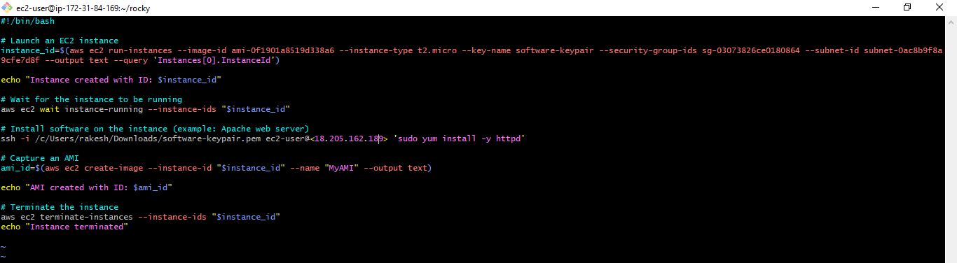

Here in this image shown that ec instance created ID is Last 4 digit ***51a2 and terminated as per script***

